# ArrayList Extension Lab

## Create Stats.java

Create a Stats class with a constructor which will be passed a reference to an ArrayList<Double>.

Your file will support the following methods, all using the ArrayList<Double> passed in via the constructor:

* **public** **double** getMean()
* **public** **double** getStdDeviation()
* **public** **double** getMode()
* **public** **double** getMax()
* **public** **double** getMin()
* **public** String toString()

To implement the Standard Deviation method, use the following formula:

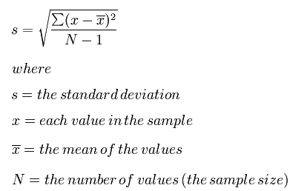

The mode of a given data set is the number which has highest number of occurrences. For example, given {5, 4, 3, 5, 3, 5, 6} 5 is the mode because it occurs the most often (3 times). To implement the getMode() method, you will need the ability of maintaining a count of each number within the given ArrayList.

The toString() method should return a String similar to the one found below. The actual results use statsData.txt.

Enter a file name (without .txt): statsData

Average .............. 46.64

Standard deviation ... 18.39

Mode ................. 37.80

Max value ............ 90.40

Min value ............ 5.70

Make sure you inspect the data to confirm the numbers are reasonably correct. When developing a program, you should know what reasonable output is.

You can use the following toString() method, which uses the String.format() method to format the doubles. The term: %8.2f will format a double or float with 8 total characters and 2 decimal places. It will automatically round up to the 2 decimal places.

**public** String toString()

{

String str = "";

str += String.*format*("Average .............. %8.2f\n", getMean());

str += String.*format*("Standard deviation ... %8.2f\n", getStdDeviation());

str += String.*format*("Mode ................. %8.2f\n", getMode());

str += String.*format*("Max value ............ %8.2f\n", getMax());

str += String.*format*("Min value ............ %8.2f\n", getMin());

**return** str;

}

Use ArrayListBasics.java to read in a data file, create an ArrayList<Double>, then create a new Stats object with the new ArrayList object. When you print out the reference of the Stats object, the toString() method will be called by the JVM, and the results should be displayed. Compare with the results shown of the previous page.